Meta Title:
Buy Certified IWC watch at Swiss Ice
Meta Description:
Shop unique Pre owned IWC watches available for sale at Swiss Ice Co. Explore our collection of superb watches ranging from IWC Big Pilot to Portugieser.
Watches IWC | https://swissiceco.com/collections/watches-iwc | IWC watch  Pre owned IWC watch  IWC watch price  buy IWC watch  buy IWC watch for sale  buy IWC watch for men
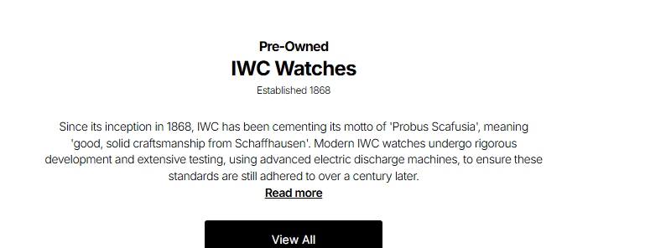

IWC Watch
Have you ever wished to own that special watch that will take your dressing to the next level? Welcome to Swiss Ice Co, where we offer you a stunning range of used IWC watches. With an extensive range of IWC pilot watches and the classic IWC Portuguese, we have the perfect range of authentic pre owned IWC watches that you are guaranteed to love.

Shop Now

Discover the Mystery Surrounding IWC’s Most Desired Models:
Since the cutting-edge combination of tradition, innovation, and design, some of the most sought watches have stemmed from IWC. At Swiss Ice Co, we are excited and delighted to bring to the market a touch of an enigma behind some of today's pre owned IWC watches.

With faces ranging from the timeless sophistication of the IWC Portugieser Chronograph to the technically adventurous Big Pilot’s Watch, the Swiss Ice Co offers a wide stylistic variety for aficionados of this respected brand. From our stores, you can be assured that the IWC watch price is less than the competitors', so you can afford it without breaking your bank.

IWC Big Pilot: A Prestigious Aura on the Wrist
The IWC Big Pilot clocks are from the Pilot’s watch collection, reflecting aviation mechanical history as it suggests the first all-metal aircraft. The Big Pilot collection is a synonym of magnitude and sophistication which, in turn, was derived from the inventiveness of pilots who conquered the skies. Our pre-owned IWC Big Pilot watches capture the essence of this iconic collection, with features such as large diameter, the layout of the dials, and crown shape of the lever.

IWC Portugieser: A Reflection of Time Itself
The IWC Portugieser was first launched in 1939 and has since assured elegance, pin-point accuracy, and exquisite sophistication. Based on Portuguese traders' desire for a more accurate timepiece, the Portugieser still retains this element of the explorer. Swiss Ice Co has an excellent collection of used IWC Portugieser watches that represent a dedication to the craftsmanship of the Swiss watch brand.

Experience Horological Craftsmanship With Unbeatable Prices:

At Swiss Ice Co, we firmly believe that wearing an IWC model, whether it is an IWC Portugieser or an IWC Big Pilot, carries a different aura for every buyer. The IWC brand remains iconic for the production of luxury watches, but we have cherry-picked the secondhand IWC watches so that everyone can own a part of horological history.

All the pre-owned IWC watches we offer are purchased from reputable dealers to ensure that they are in excellent shape as the first time they were sold. A team of professionals assembles and handles these timepieces so that our customers get the best when they buy IWC watches from our stores in San Francisco or Los Angeles.

Embrace the IWC Legacy: Buy a Vintage IWC Watch from Swiss Ice Co
What happened to the IWC Portugieser, the Pilot’s Watch, the Big Pilot? Every single watch in the line tells a tale. When you buy an IWC watch for sale from Swiss Ice Co, you join other people who are part of the IWC's interesting story. Choose from our fantastic range of pre-owned IWC watches and become part of a timeless tradition of highly skilled horological craftsmanship that the company upholds.

At Swiss Ice Co, we work hard to give you the very best used IWC watches to entice and motivate you. We encourage you to learn about the flawless beauty, unparalleled craftsmanship, and timelessly dependable IWC watches and enter into the rich tradition. So, why wait? Buy an IWC watch for men from Swiss Ice Co and be a part of the IWC legacy.
